STEP 1: GO TO EC2 UNDER SERVICES

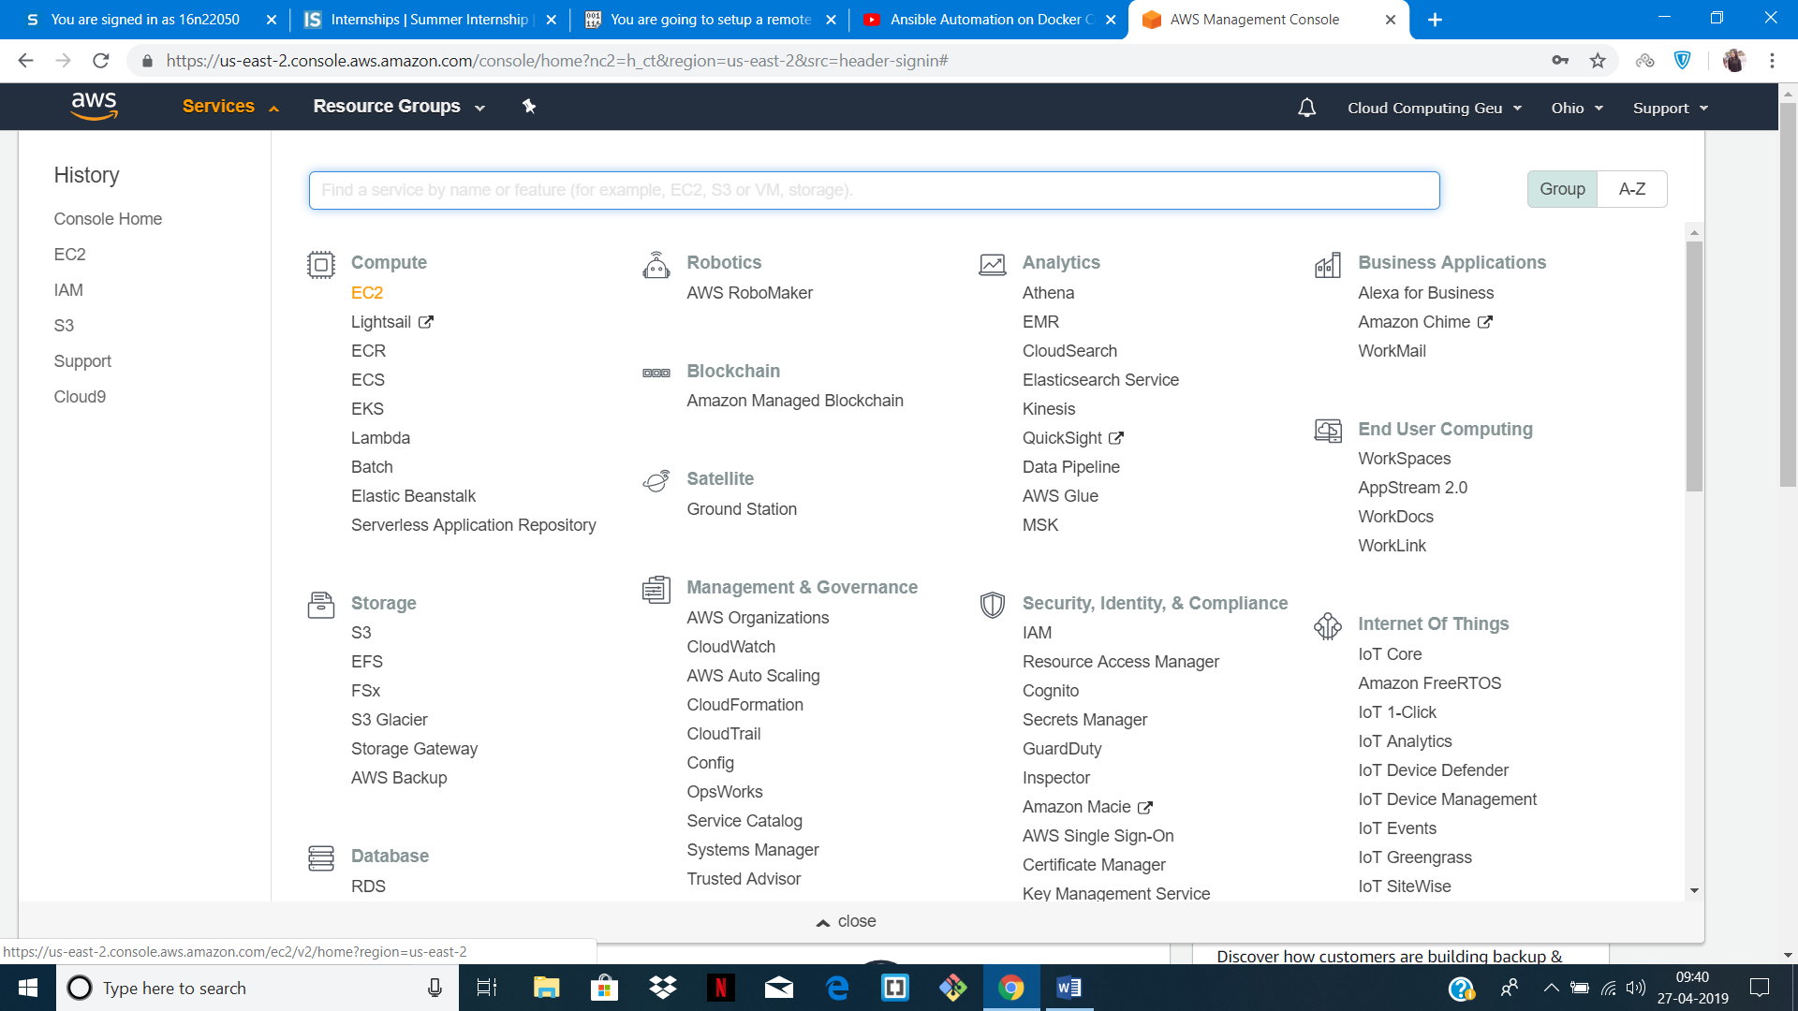

STEP 2: SELECT UBUNTU IMAGE

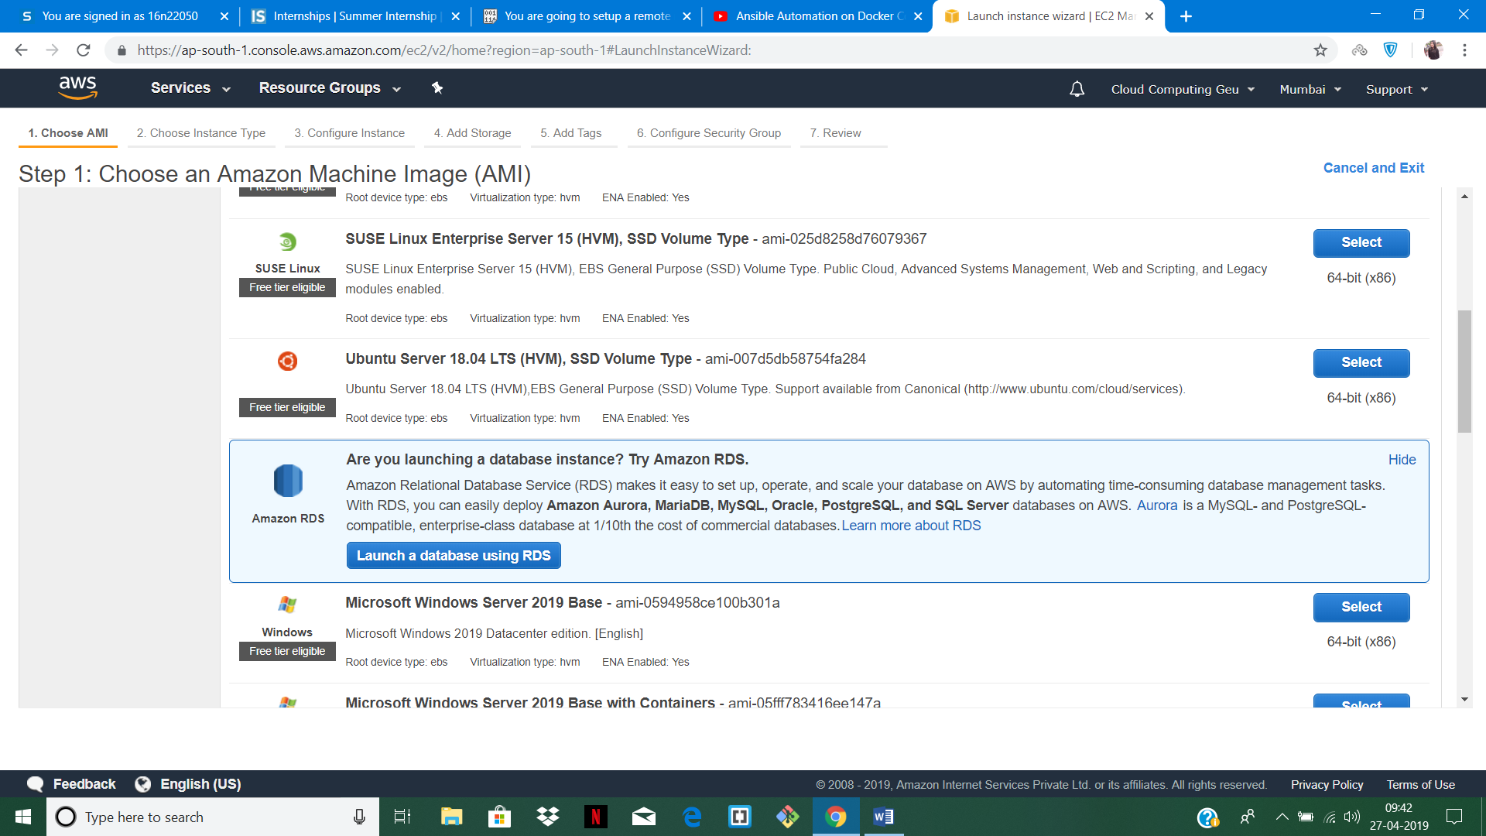

STEP 3: SELECT FREE TIER INSTANCE TYPE

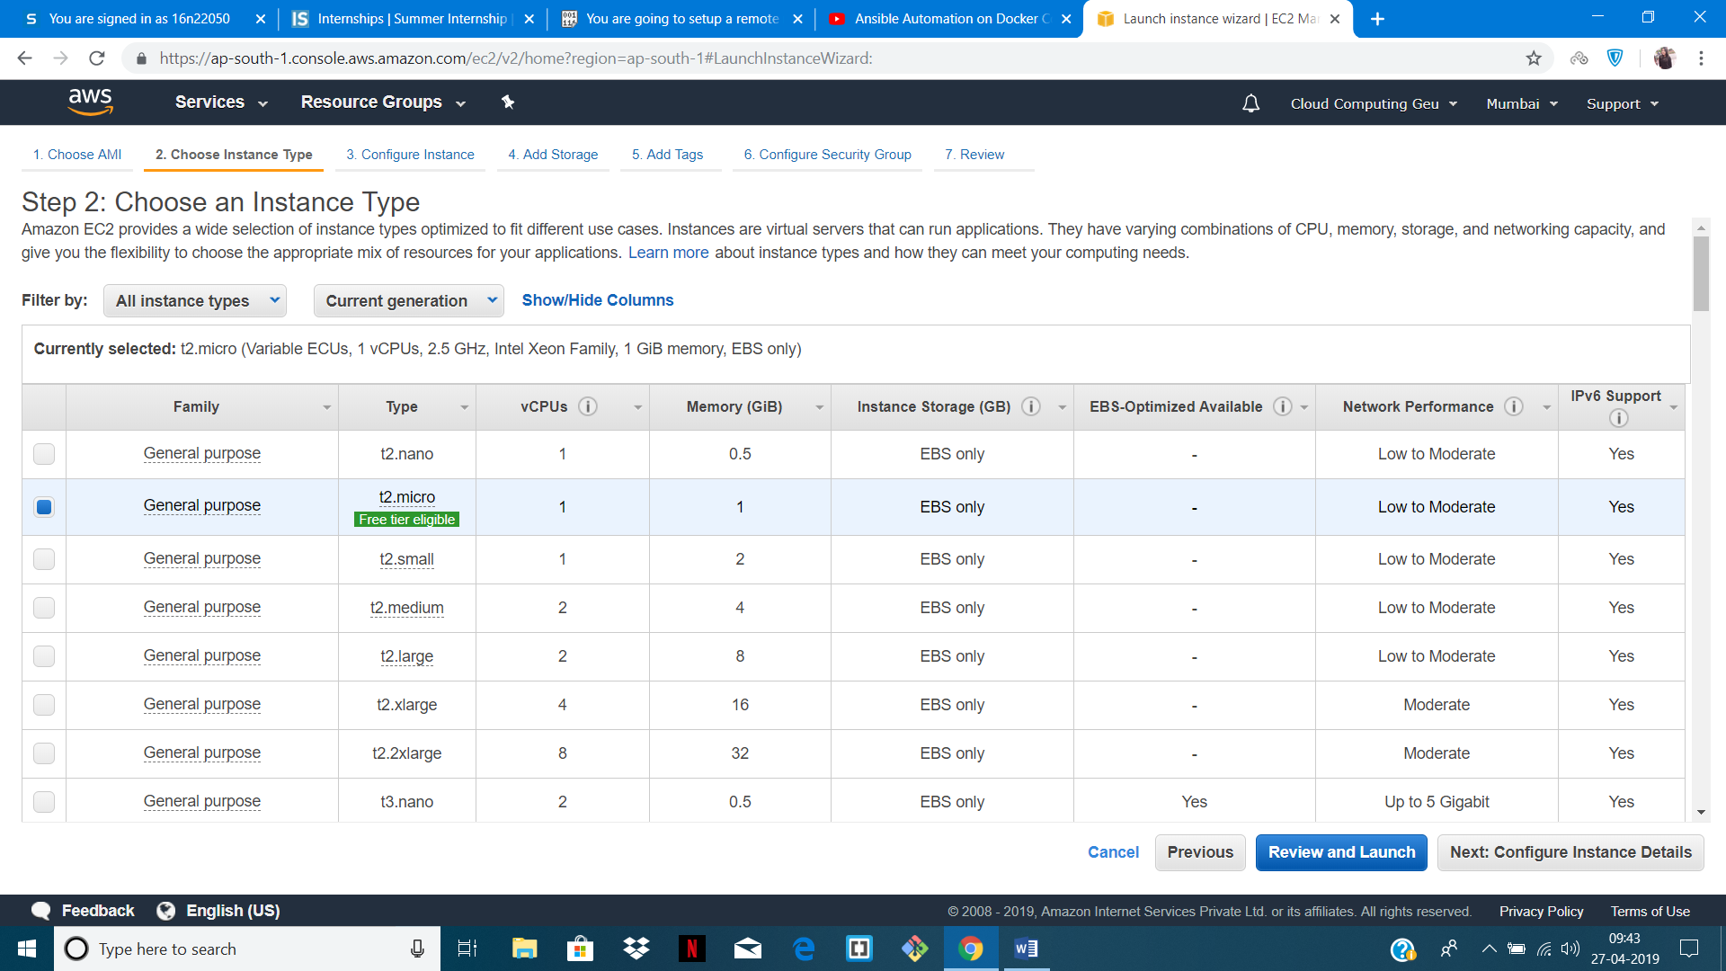

STEP 4: GO TO CONFIGURE SECURITY GROUP AND MAKE SOUCE ANYWHRE

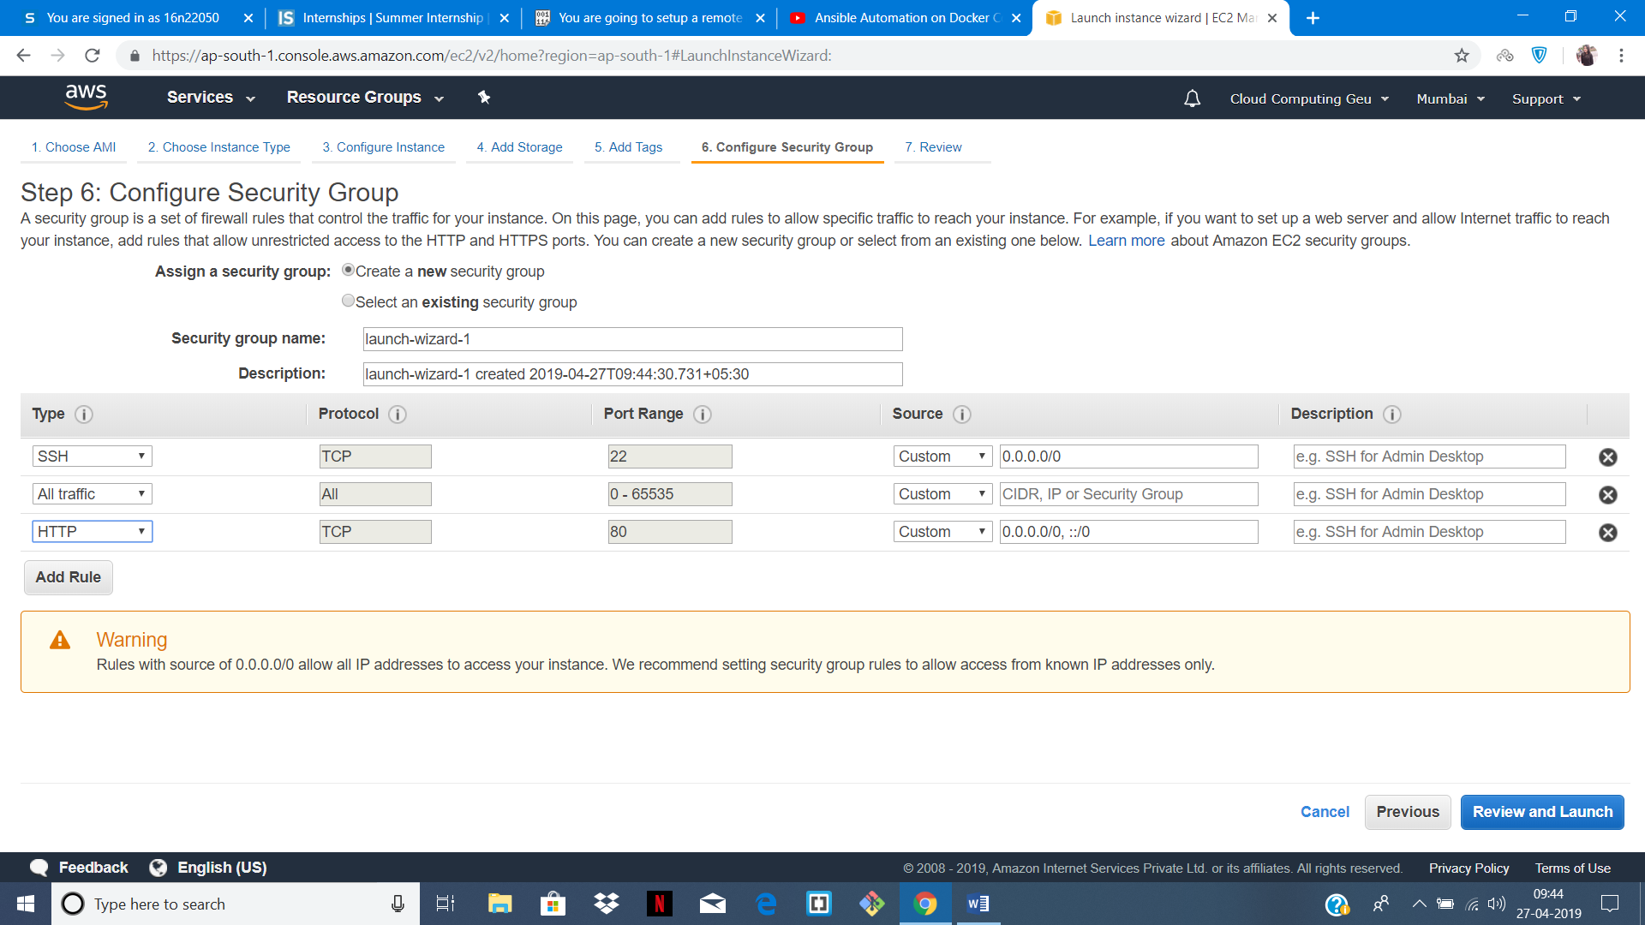

STEP 5: DOWNLOAD THE KEY PAIR

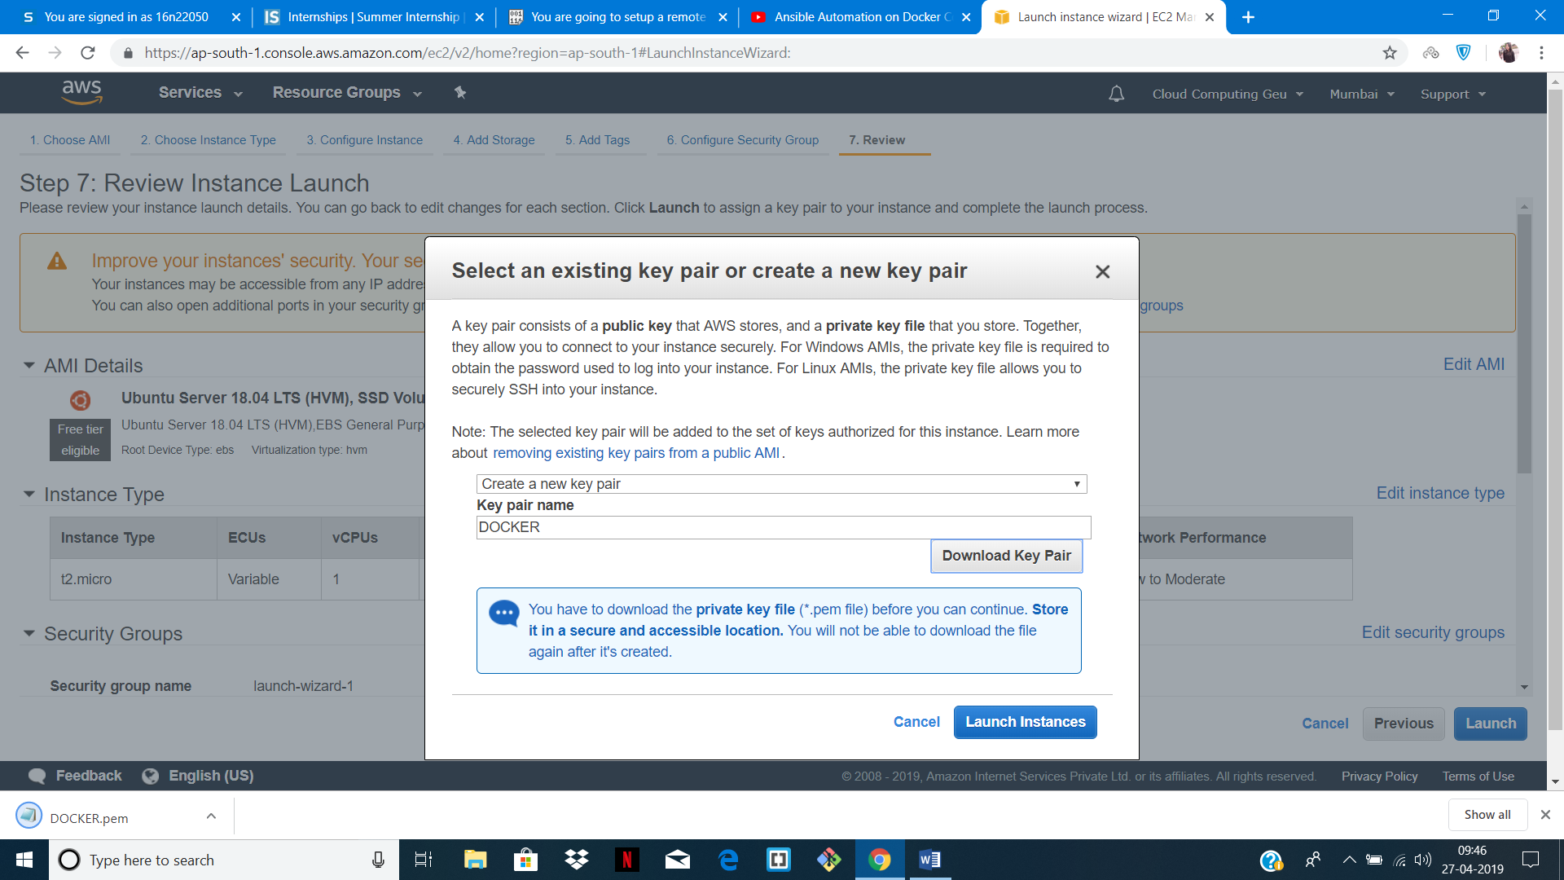

STEP 6: OPEN PUTTY IN HOST COPY DNS NAME

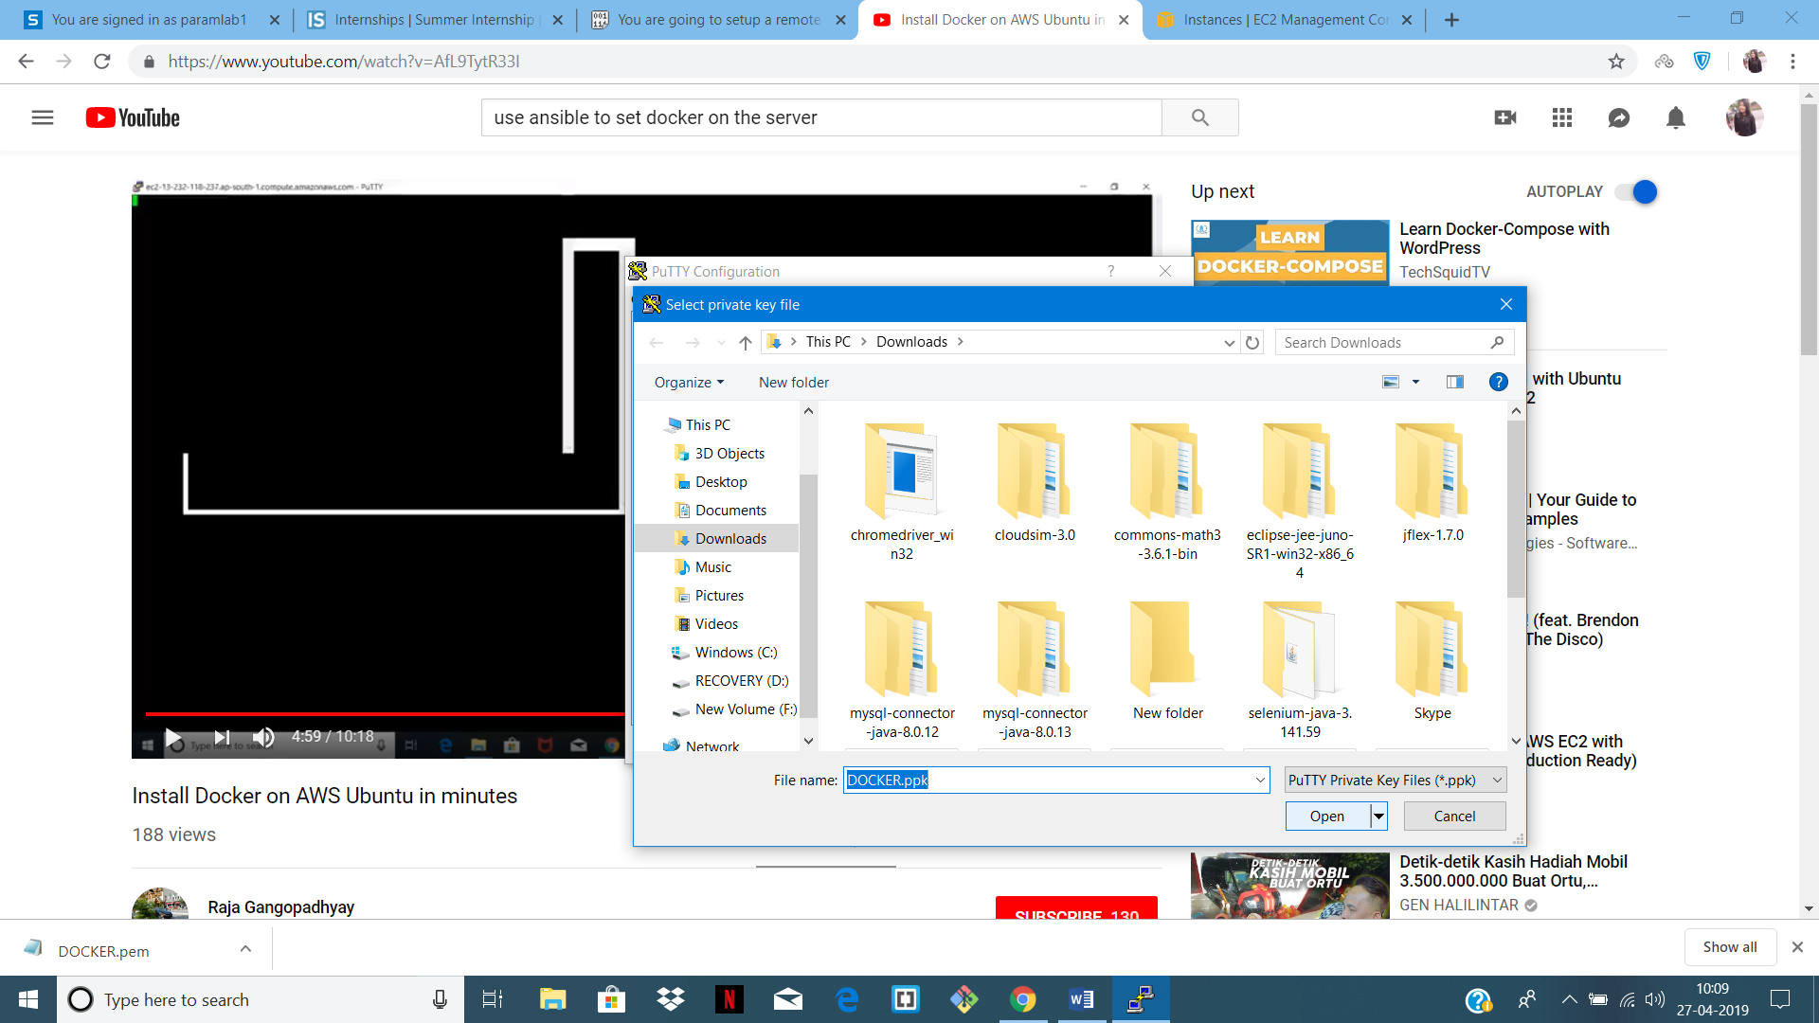

STEP 7: USER NAME WILL BE UBUNTU

